THE SKEPTIC ARENA.COM
June 28, 2014

Taken from the "About" page of Ken Ammi
host of the web site: "truefreethinker.com"

Then Jesus said to those Jews who believed Him,
"If you abide in My word, you are My disciples indeed.
And you shall know the truth, and the truth shall make you free"
John 8:31-32

Ken, I prefer these 2 verses that Jesus spoke to those Jews who believed in Him:
"For the Son of man shall come in the glory of his Father with his angels; and then he shall reward every man according to his works.
Verily I say unto you, There be some standing here, which shall not taste of death, till they see the Son of man coming in his kingdom."
Matthew 16:27-28

Well Ken, it's 2,000 years later and we now know that Jesus lied to them. If the truth shall make you free, as Jesus said, then
the truth of knowing that Jesus lied has set many former Ghost Worshipers free. Too bad you weren't one of them, Ken.

Below you will find information about me, about True Free Thinker, and about how to book me for lectures:

Ken, if I ever want my kids lectured on fairy tales, I'll be sure to consider your offer.

My name is Ken Ammi. True Freethinker presents my writings. I am an Argentinean-American , a Jewish-Christian, an essayist and lecturer. While I was raised in a 100% secular manner,

Ken, I'm sorry to hear that. That removes all possibility of trying to place the blame on your parents, and puts the entire burden of your failure ... on you.

I did attend private Jewish school and had my Bar Mitzvah in Israel (only secular Jews may be able to understand this oddity). I was also involved in the New Age Movement and was a practitioner of Reiki, Tai Chi Chuan, Chi Kung and the I'Ching.

Ken, so in addition to your religious delusion, you've also got a host of other bullshit sloshing around in your head.

(A psychiatrist would have an easier time with the Labors of Hercules than trying to troubleshoot the tangle of wiring in that skull)

The True Freethinker website consists of a combination of a few different blogs that I was authoring; the main ones were the Christian Apologetics blog "Life and Doctrine" and the contra atheism blog "Atheism is Dead."

See Ken, that's what I meant earlier when I referred to your delusions. The fasting growing segment of the population, Atheism, both here in the U.S., and worldwide, is in your mind ... dead.

Could you possibly be any more divorced from reality?

That was a rhetorical question, Ken.

The concept of freethinking is deeply rooted in the Bible itself

Ken, I'm going to have to give you a "time out."

From Dictionary.com - freethinker:
"A person who forms opinions on the basis of reason, independent of authority or tradition, especially a person whose religious opinions differ from established belief."

Synonyms: skeptic, agnostic; atheist.

See Ken, it works like this. You don't get to define words to make them mean what you wish they meant. According to the dictionary, you are as far from being a freethinker as Donald Sterling is, from receiving an NAACP award.

as in the Bible, we find firm belief, we find doubt, we find skepticism, we find rebellion, we find every facet of human reactions towards, and against, the divine. Some people label themselves "skeptic" when they really mean "cynic."

Ken, that's why I don't really like the term "skeptic." One example would be global warming skeptics: they believe the exact opposite of what the actual skeptical community believes.

I prefer the term Rationalist.

I, for one, became a true and honest skeptic upon finding out that the Teeth Mice, Argentina's equivalent of the Tooth Fairy, were not real; my parents had told me a quaint story about them leaving money for my teeth.

Ken, you sure set the bar awfully low. You found out that the tooth fairy wasn't real, so you promoted yourself immediately to full-fledged skeptic. I would call that a good first step. However, your failure to apply that same skepticism to your religious beliefs proves that you never went any further after the trauma of learning the truth about those quarters under your pillow.

At a very young age I found out that they were not real and that my parents, with good motives, had deceived me and I became furious.

Ken, you got furious with your parents because they dashed your dreams about the tooth fairy?

Holy shit dude. No wonder your mind is like a sack of leftover pork chops.

How pleased I was to find, decades later, that the Bible enjoins true and honest skepticism:

Aw. Widdle Kenny feel all better now. You lost the tooth fairy, but now you've got someone better ... another invisible friend.

" 'Come now, let us reason together,' says the LORD" (Isaiah 1:18), in the New Testament the Bereans are considered more noble (or more "fair minded") for double checking everything that Paul told them (Acts 17:11)

Ken, here is Acts 17:11,
"These were more noble than those in Thessalonica, in that they received the word with all readiness of mind, and searched the scriptures daily, whether those things were so."

Ken, they weren't more open-minded - they were simply more open to scriptural brainwashing. That isn't the same thing, Ken.

Thomas asked for the evidence which the others had seen and had merely retold to him (John 20:24-30)

Ken, it doesn't sound like you've ever read Hebrews 11:1
"Now faith is the substance of things hoped for, the evidence of things not seen."

I guess Thomas pretty much failed the "Faith" test, huh Ken?

Jesus stated, "Love the Lord your God with all your...mind. This is the first and greatest commandment" (Matthew 22:36-38).

Hey Ken, why don't you tell everyone what God will do to them ... if they don't?

We are clearly called to discern, test, and judge

Ken, but if you don't reach the proper conclusion - it's off to ... "The Big Barbecue."

“Let two or three prophets speak, and let the others judge”
(1st Corinthians 14:29).

Ken, I like this one better -
"Judge not, that ye be not judged."
Matthew 7:1

So Ken, should we believe your verse written by Paul? Or my verse ... written by the Son of God?

One of the gifts of the Holy Spirit is “discerning of spirits”
(1st Corinthians 12:10).

Ken, I think he meant to write "distilling of spirits."

“Dear friends, do not believe every spirit, but test the spirits to see whether they are from God, because many false prophets have gone out into the world” (1st John 4:1).

Ken, each and every one of you Ghost Worshipers is a false prophet. There isn't one speck of evidence anywhere on the planet to prove that your delusions exist anywhere outside your heads.

There is just as much evidence for your tooth fairy or teeth mice.

But Ken, between those two ghosts, you should have stuck with the nice one that gives money to little kids, rather than the nasty one who brags about all the people He's murdered and the billions He plans to torture.

“Do not quench the Spirit. Do not despise prophecies.

Ken, check out this prophecy, from Genesis 22:17,
"That in blessing I will bless thee, and in multiplying I will multiply thy seed as the stars of the heaven, and as the sand which is upon the sea shore...."

Ken, contrary to the prophecy, the Jews are one of the smallest ethnic groups on Earth. Even the Mormons outnumber them and the Mormons didn't get started until the 19th century.

I guess that's what they mean by "Like Father - like Son."

Neither one of your invisible ghosts has been able to predict squat.

Much of what passes for "Freethought" and "Freethinking" today is, in reality, atheism wearing a very thin disguise.

Ken, a disguise is unnecessary. As I documented earlier, Atheism is a synonym for free thought. That's what makes it so hilarious when you try to pass yourself off as a free thinker, while simultaneously having conversations with your imaginary friends.

The first section of the parsed essay Freethought Without Forethought? serves as evidence of this. In that case, it is clear that what is meant by Freethought is adhering to absolute materialism. If a Judeo-Christian cannot be a freethinker then freethought is not freethought but demands adherences to certain restrictive parameters.

Ken, that is true of everything. To be classified in a certain category - one must meet certain requirements.

As for free thinking, Ken ... you missed the cut.

Yet, since the Judeo-Christian can think beyond, for example, materialistic parameters we can be true freethinkers.

No Ken, free thinking does not include delusions. Reread the definition.

Atheists who have commandeered the term Freethought

Ken, Atheists didn't commandeer the term "free thought" - Noah Webster did.

complain that Christians cannot be Freethinkers because they adhere to the Christian worldview.

Ken, Atheists are not complaining. We are just fine with the definition as it stands. You are the one bending yourself into a pretzel trying to redefine the word.

Yet, they commit the same alleged fallacy by adhering to atheism in disguise (or openly).

Ken, Atheism is not something you can "adhere to." It is a rejection of religious bullshit - nothing more.

Certainly, there are true and honest Freethinkers on both, and many other, sides of the issue.

Ken, not according to the definition.

It is to these that this website is dedicated.

Ken, your web site is to free thinking ...
as fracking is to renewable energy.

Feel free to contact me if you wish to have me present one or more lectures. As you can see from the contents of True Freethinker I have researched a great variety of religions and worldviews so feel free to recommend a topic and set up a lecture (or series of lectures).

Ken, the only way I would ever try to convince someone to attend one of your lectures, is if I wanted to punish them. Now run along and play with your imaginary friends.

Here's a picture of Ken -

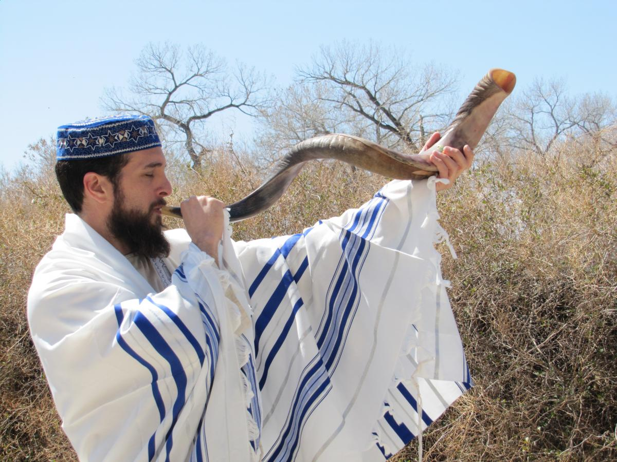

Ghost Worshipers really are a special kind of crazy ... aren't they?

And here's Ken giving one of his brainwashing lectures.

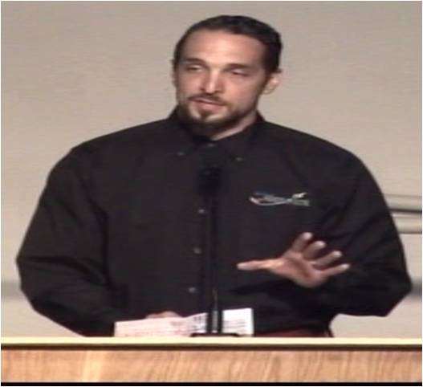

"Now let me tell you about this invisible guy who created the universe using His magic powers. But one word of warning: do NOT ... piss Him off!"

****************************************************

THE SCIENCE SEGMENT

Sleep behavior disorder linked to brain disease

Researchers say a sleep disorder that causes people to act out their dreams is the best current predictor of brain diseases like Parkinson's and Alzheimer's.

Rapid-eye-movement sleep behavior disorder (RBD) is not just a precursor but also a critical warning sign of neurodegeneration that can lead to brain disease. In fact, as many as 80 to 90 per cent of people with RBD will develop a brain disease.

As the name suggests, the disturbance occurs during the rapid-eye-movement stage of sleep and causes people to act out their dreams, often resulting in injury to themselves and/or bed partner. In healthy brains, muscles are temporarily paralyzed during sleep to prevent this from happening.

It's important for clinicians to recognize RBD as a potential indication of brain disease in order to diagnose patients at an earlier stage. This is important because drugs that reduce neurodegeneration could be used in RBD patients to prevent (or protect) them from developing more severe degenerative disorders.

This research examines the idea that neurodegeneration might first affect areas of the brain that control sleep before attacking brain areas that cause more common brain diseases like Alzheimer's.
****************************************************

FAMOUS QUOTES

ANONYMOUS

"Since the Bible and the church are obviously mistaken
in telling us where we came from,
how can we trust them to tell us where we are going?"

